**Online Education Employment (Android) Project**

**Project Management Plan**

Version: 1.0

Date: 12 Aug. 2015

Document Modification History/Revision log

|  |  |  |  |
| --- | --- | --- | --- |
| Version | Date | Author | Description of Change |
| 1.0 | 12/08/2015 | VEL team | Initial version |
|  |  |  |  |
|  |  |  |  |
|  |  |  |  |
|  |  |  |  |

Contents

1. Introduction 3

1.1. Project Overview 3

1.2. Project Approach 3

1.3. Project Practices 3

1.4. Project Artefacts 4

2. Requirement 5

2.1. Product Backlog 5

2.2. Sprint Backlog 5

3. Project Timetable and Schedule Monitoring 6

3.1. Client Meeting Plan 6

3.2. Team Meeting Plan 6

3.3. Project Development Plan 6

3.4. Risk Management Plan 6

3.5. Change Management Plan 7

4. Project Configuration 8

4.1. Plan Management Tool 8

4.2. Source Management Tool 9

# Introduction

This Project Management Plan applies to the project “Online Education Employment (Android) Project”. The Project Management Plan is required reading of all team members of this project. The current version of the Project Management Plan is located at GitHub “761_VEL”. The plan is a living document that is updated when changes are made to the scope of the project.

## Project Overview

**Overall Project Goal:**

The goal of this project is to create an adaptive (mobile friendly) website to help IT students and unemployed people to get useful skills. The home page should show some successful stories and draw visitors’ attention so that they would like to register as fixed users.

**Major Capabilities:**

1. The visitor can view the website and scan the course list. They can also take a test without registering.
2. The system (course advisor) can give the user a short survey and then give a list of successful examples about those who found a job after taking courses on the website and recommend some suitable courses according to the survey.
3. The user can select courses and make payments online. After that they can take courses via video or audio.

## Project Approach

The project will use a customized agile development model. It includes releasing planning phase, design phase and 3 prints. . The tasks in every sprint include designing, coding, testing, sprint review and retrospective.

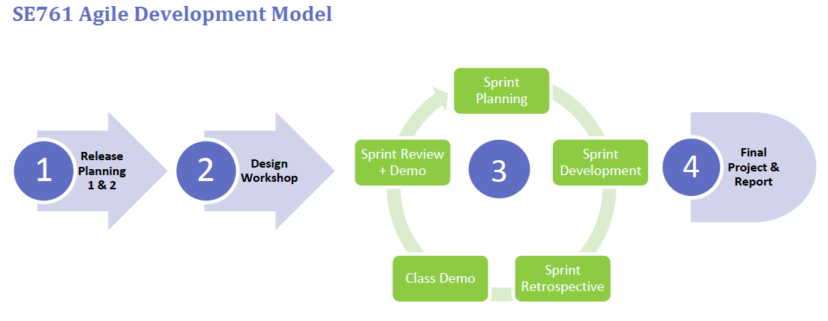

## Project Practices

The following core practices will be applied to this project.

1. Release Planning
2. Sprint Planning
3. Daily Scrum
4. Self-assignment
5. Cross-functionality
6. Work-in-Progress Limits
7. Rotating Scrum Master
8. Pair Programming
9. Architectural Spikes
10. Sprint Review (including Demo)
11. Retrospective

## Project Artefacts

The project will use these following agile artefacts.

1. Product Backlog
2. Sprint Backlog
3. User Stories
4. Tasks
5. Release Plan
6. Design Documents
7. Scrum Board
8. Burn-down charts

# Requirement



## Product Backlog

## Sprint Backlog

# Project Timetable and Schedule Monitoring



## Client Meeting Plan

## Team Meeting Plan

Team internal communication plan defined as below:

|  |  |  |  |  |  |
| --- | --- | --- | --- | --- | --- |
| No. | Meeting | Purpose | Participant | Frequency | Time |
| 1 | Daily Scrum | Check team progress regularly | All team members | Weekly | As following |
| 2 | Sprint Planning | Confirm user stories, break it down into tasks and discuss the design of it | All team members,  Product owner | Bi-weekly | Friday,  9:00 ~ |
| 3 | Retrospective | Discuss what is good or bad in last sprint and make new strategy to improve the process | All team members,  Product owner | Bi-weekly | Friday  11:00 ~ |
| 4 | Design meeting | Discuss the architecture and design of function to make sure team members understand the details | All team members | <TBD>  Base on the result of daily scrum | <TBD> |

Timetable of regularly weekly meeting

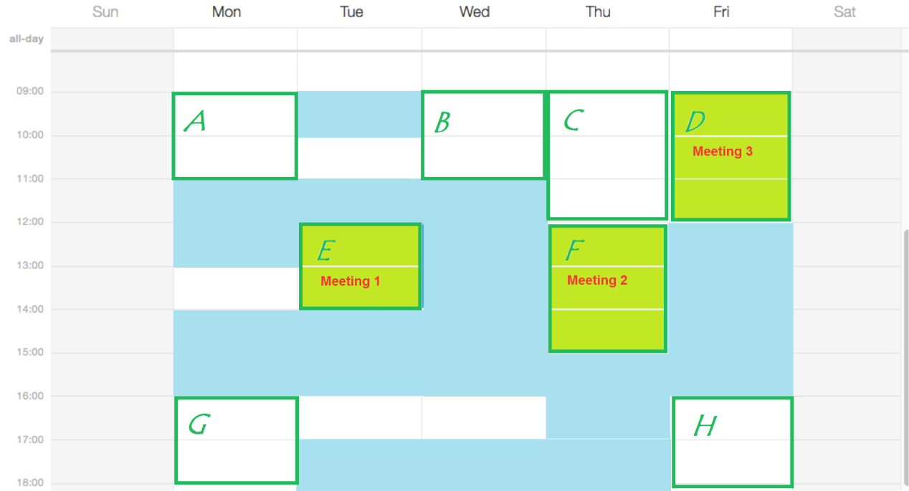

## Project Development Plan

## Risk Management Plan

Risk Management is a process that ensures any issues are identified early and addressed before they jeopardize project objectives. The process will follow all stages from creating a risk management strategy through managing risk tracking to executing a risk management plan.

The Risk Tracking will be carried out after daily scrum. It is used to manage Risks that have a significant effect on project progress and outcomes. In addition to managing Risks, the process provides a method for documenting the rationale behind risk mitigation decisions made during one stage of the project that may affect a later stage.

Supporting this process is the Risk Tracking table that provides a centralized location for tracking Risks. Documentation for this can be found in the GitHub, located /PCB/02 Plans & Actuals/2.3_Risk & Issue. The Risk Tracking Process and tool allow the user to identify and assess each risk, as well as track the progress towards mitigation.

## Change Management Plan

# Project Configuration



## Plan Management Tool

**SeeNowDo** will be used to monitor project approach, user stories, sprint plans, and development progress. Meanwhile, burn-down chart is provided to indicate whether the project is meeting its target schedule and budget.

* URL to login SeeNowDo:

<https://www.seenowdo.com/pages/login/index.xhtml>

* Project Name: **OEE(Android)**
* Image of project & iterations (sprints)

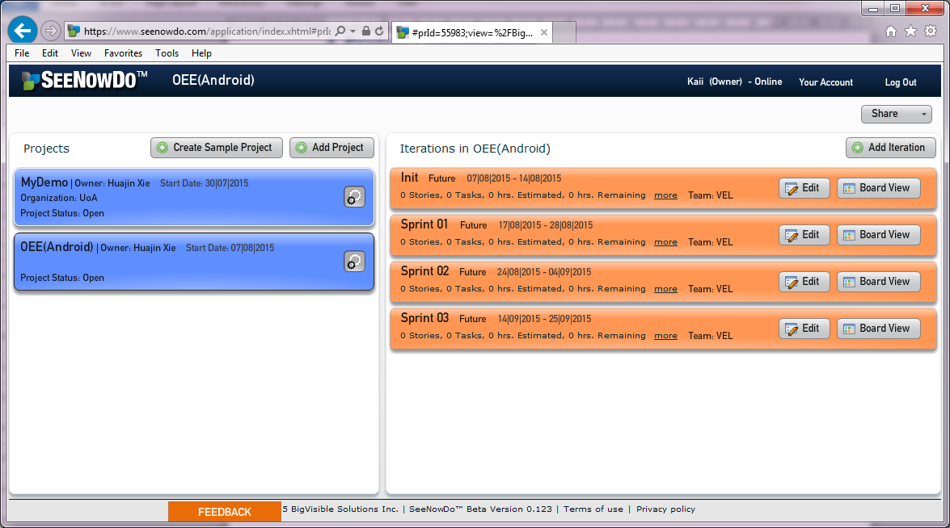

* Image of user stories & Sprint Plan

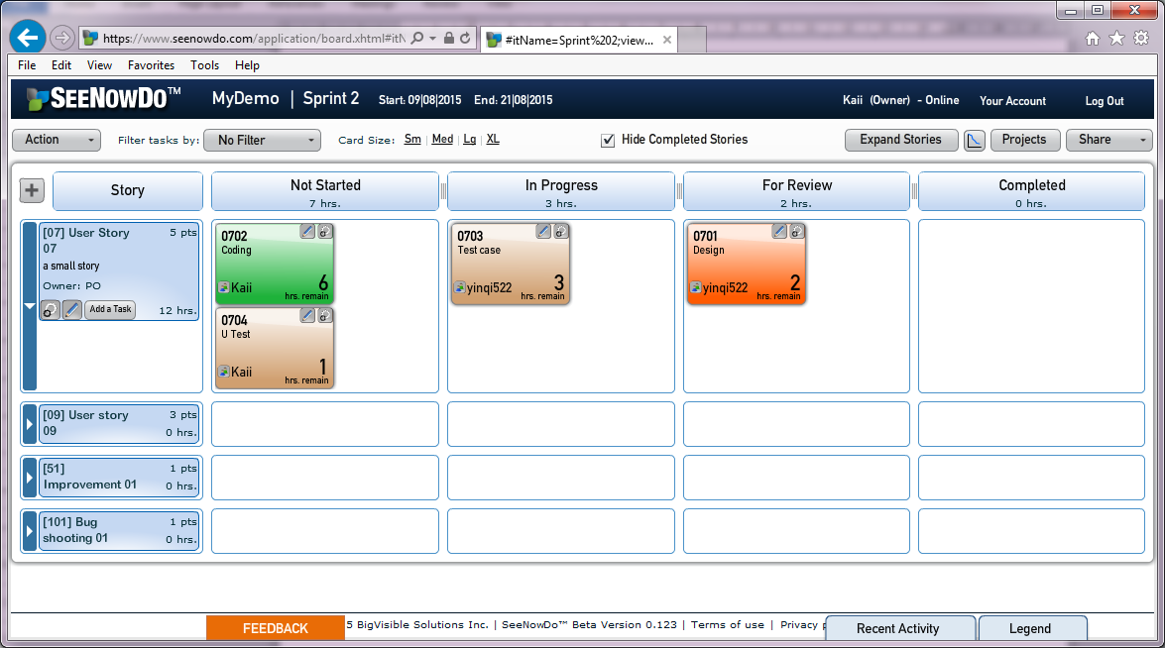

* Burn-down Chart

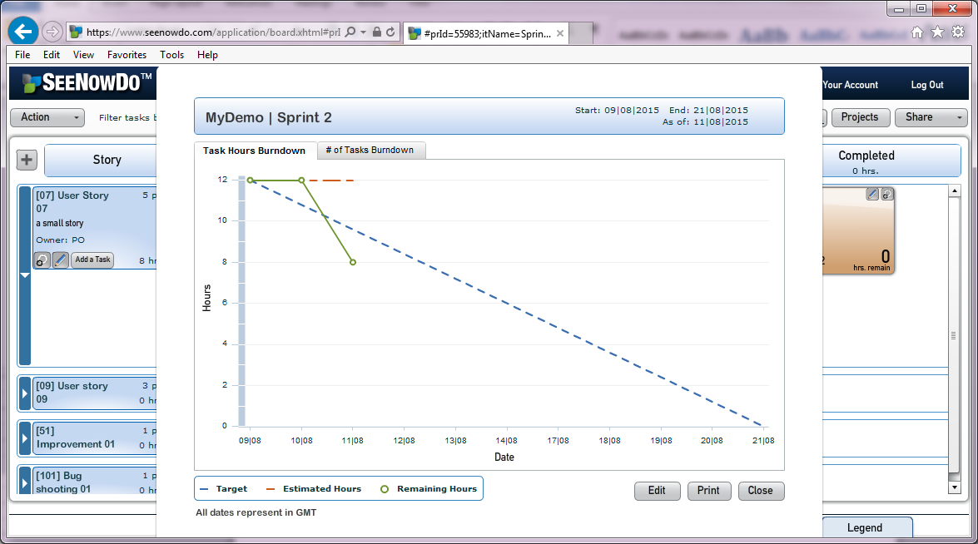

## Source Management Tool

GitHub is a Web-based Git repository hosting service. It can offer all of the functionalities of Git such as the distributed revision control and source code management (SCM). GitHub also added its own features. For example, as we’ve know, Git is strictly a command-line tool, GitHub is not. GitHub can provide a Web-based graphical interface and desktop as well as mobile integration, which is very convenient. Another superiority is that it also provides access control and several collaboration features such as bug tracking, feature requests, task management, and wikis for every project. For the develop team’s economic budget consideration, GitHub provide both plans for private repositories and free accounts.

Based on the advantages mentions above, GitHub will be used to manager our project documents and source file.

* URL to login GitHub:

<https://github.com/>

* Project Name: **761_VEL**
* Image of GitHub

